-----------BASICS----------

SQL is very easy to learn. ENJOY!!!

----1. All the cities in the Texas and the numbers of customers in each city.---

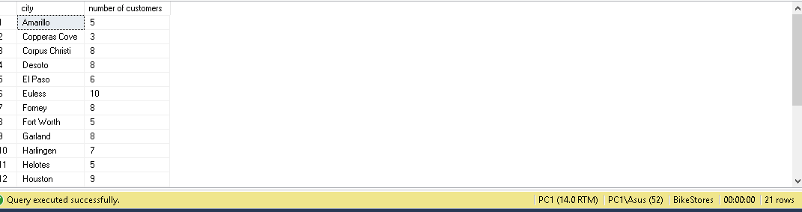

----2. All the cities in the California which has more than 5 customer, by showing the cities which have more customers first.---

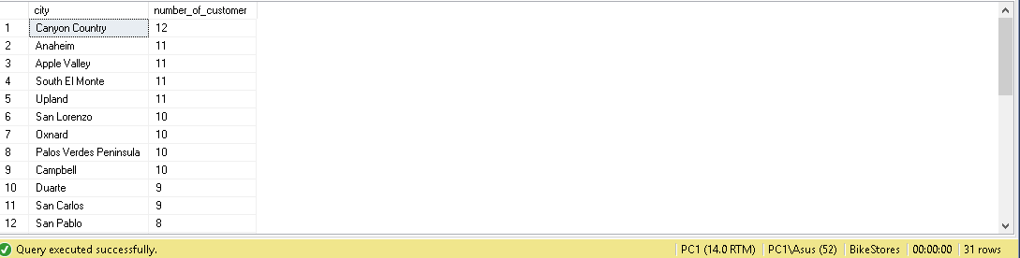

-----3. The top 10 most expensive products------

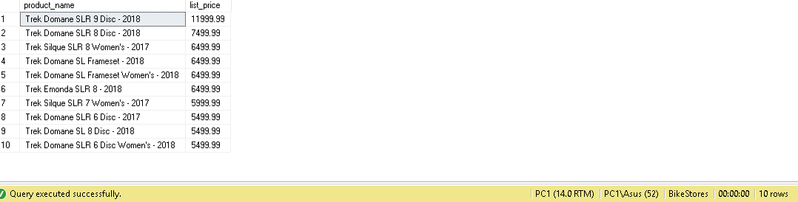

-----4. Product name and list price of the products whic are located in the store id 2 and the quantity is greater than 25------

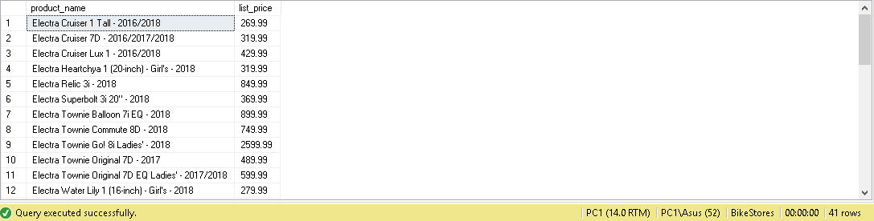

-----5. Find the customers who locate in the same zip code------

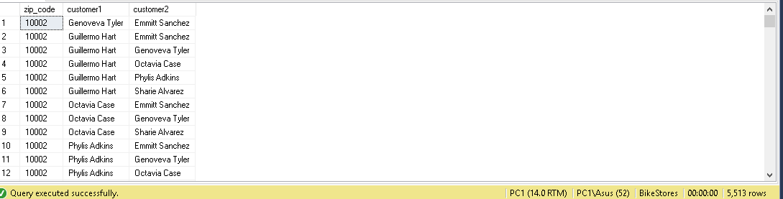

-----6. Return first name, last name, e-mail and phone number of the customers------

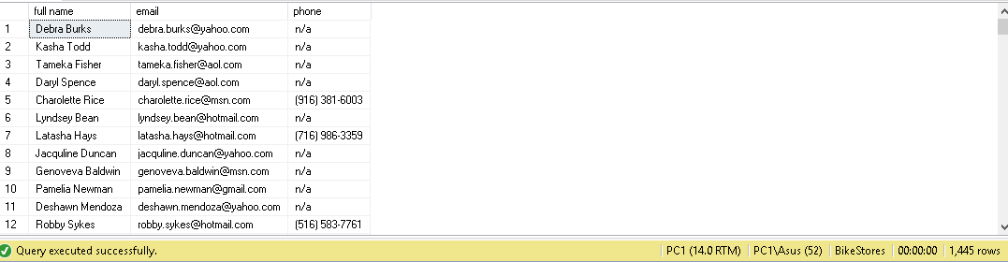

-----7. Find the sales order of the customers who lives in Houston order by order date------

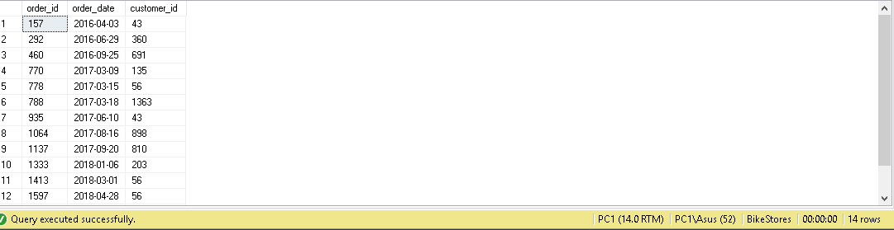

-----8. Find the products whose list price is greater than the average list price of all products with the Electra or Heller ------

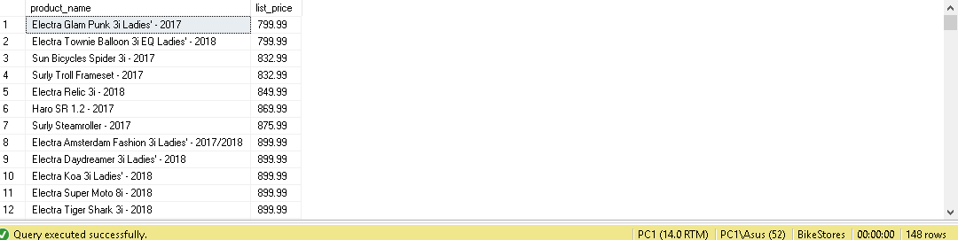

-----9. Find the products that have no sales ------

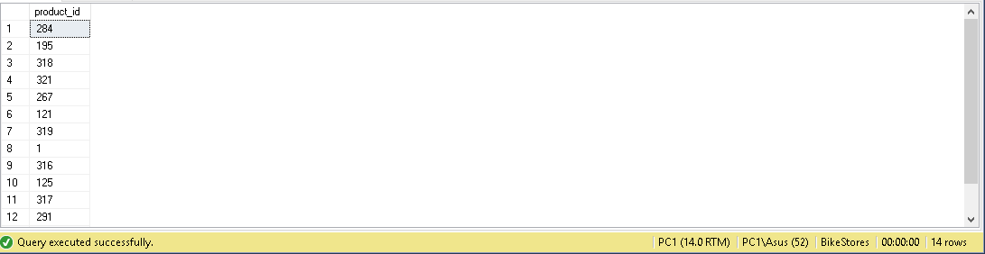

**IF YOU WANT TO IMPROVE YOUR SKILLS IN SQL TRY THESE 🡪**

---- 10. Return the average number of sales orders in 2017 sales----

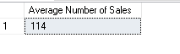

----11 By using view get the sales by staffs and years using the AVG() aggregate function:

